|  |  |
| --- | --- |
| A picture of a winding road and trees  32401108  LMothoagae | CMPG Website Documentation |

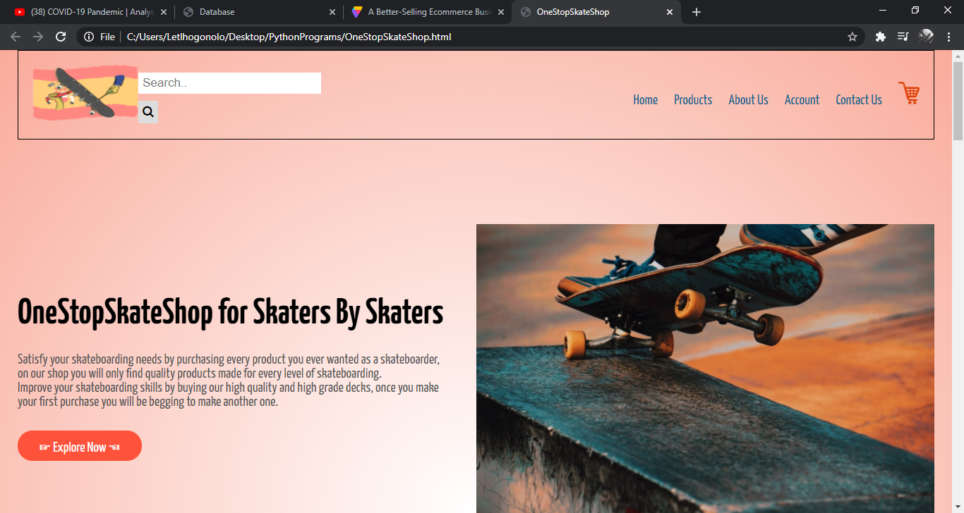

*Home Page:*

This is the first page you will come across when you open the website, the home page is called One C:PythonPrograms\OneStopSkateShop.html that is the link to the to the website where you will meet various products sold in the website, every tab within the website is fully responsive.

The Explore Now, Products and View More Tabs will send you to the All Products section web page, there is where you will find the products which are sold within the ecommerce store.

About us is where you will find detailed information about our website, and the contact us tab is where you will be able to find our contact details where you will be able to send messages to us and we will respond you.

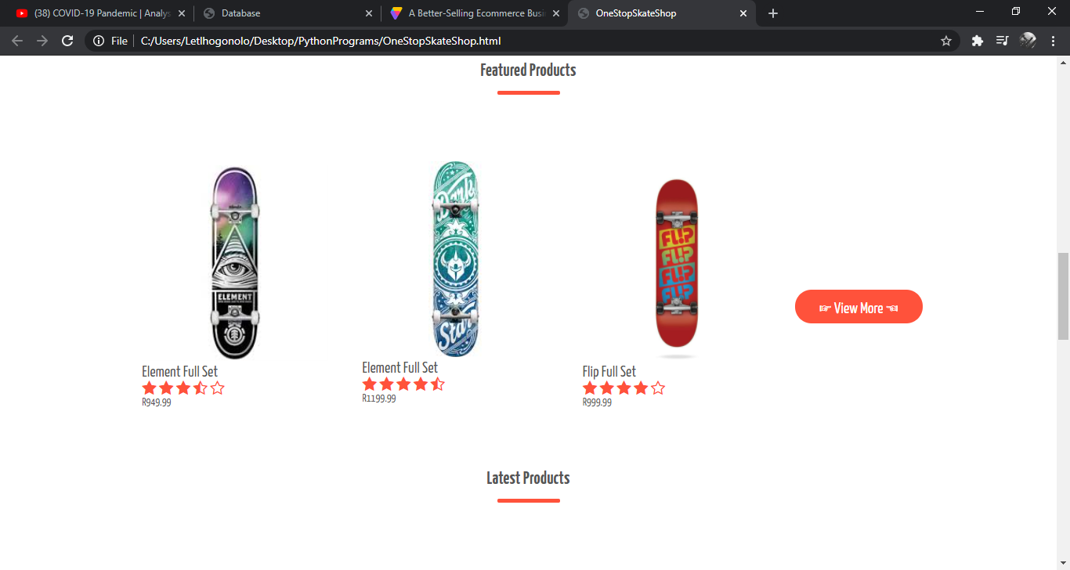

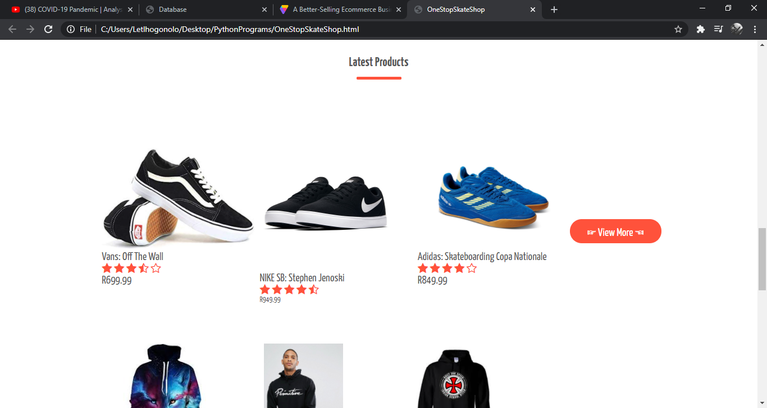

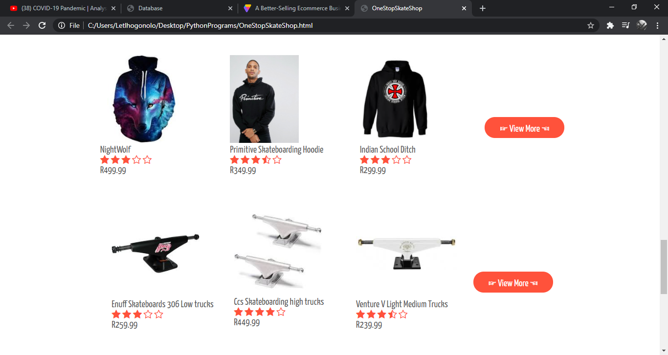

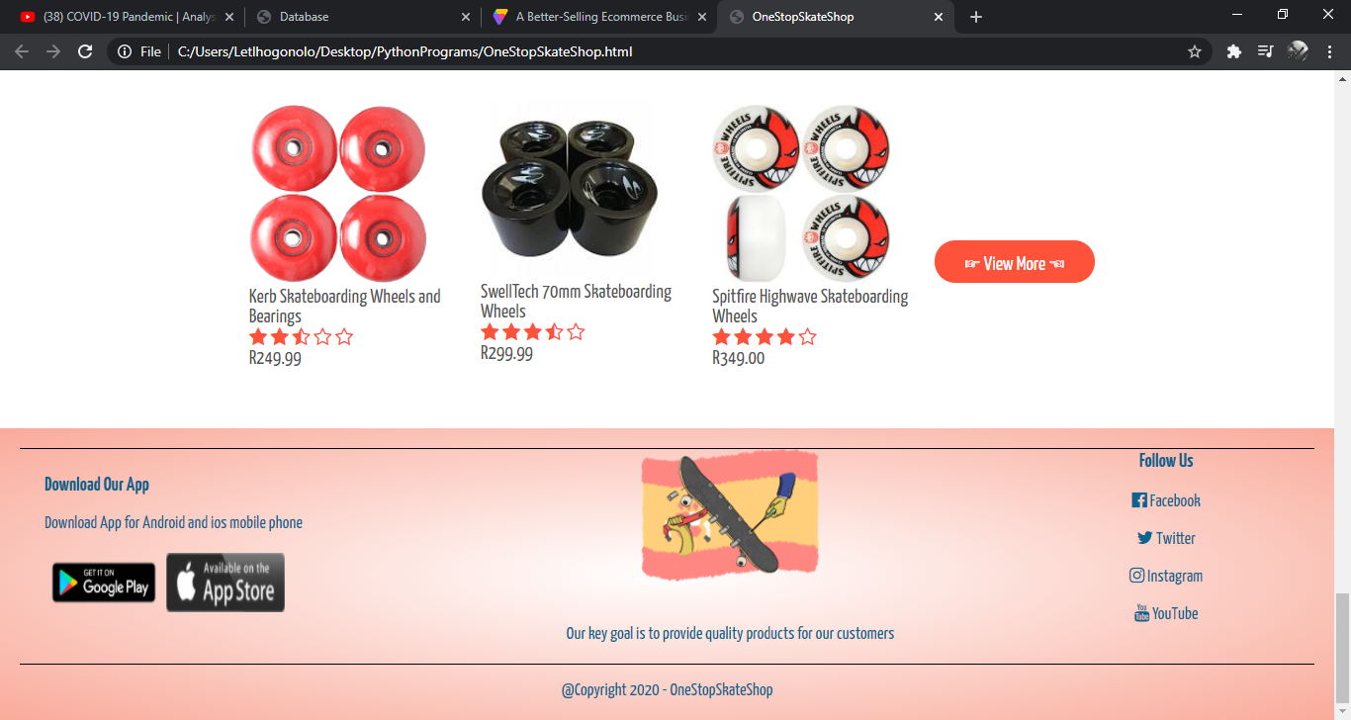

*Products Page:*

On this page is where you will find all products which are sold within the site it is where all the products are found and you can also browse through the site by clicking on the buttons at the bottom which will send you to the next page.

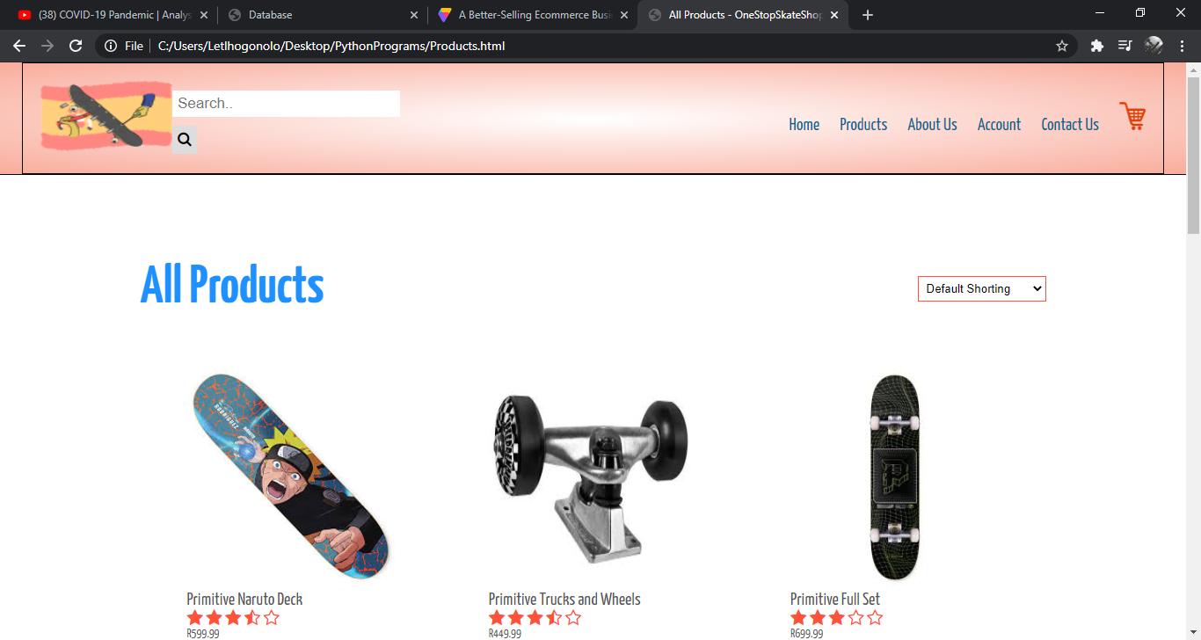

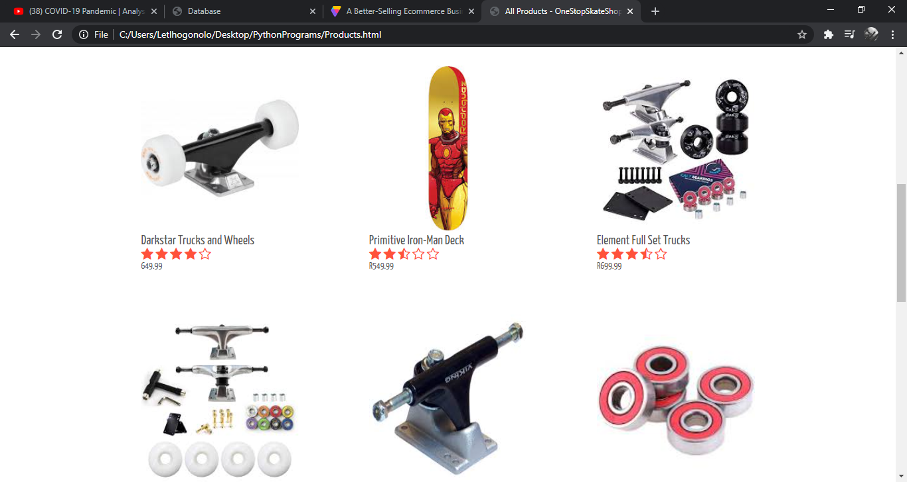

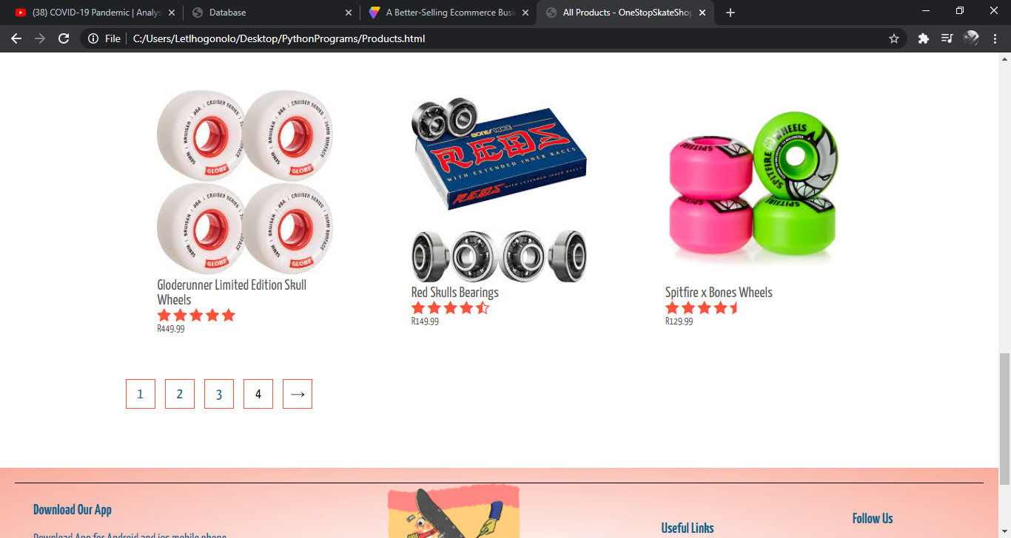

*Second Page Of The Products Page:*

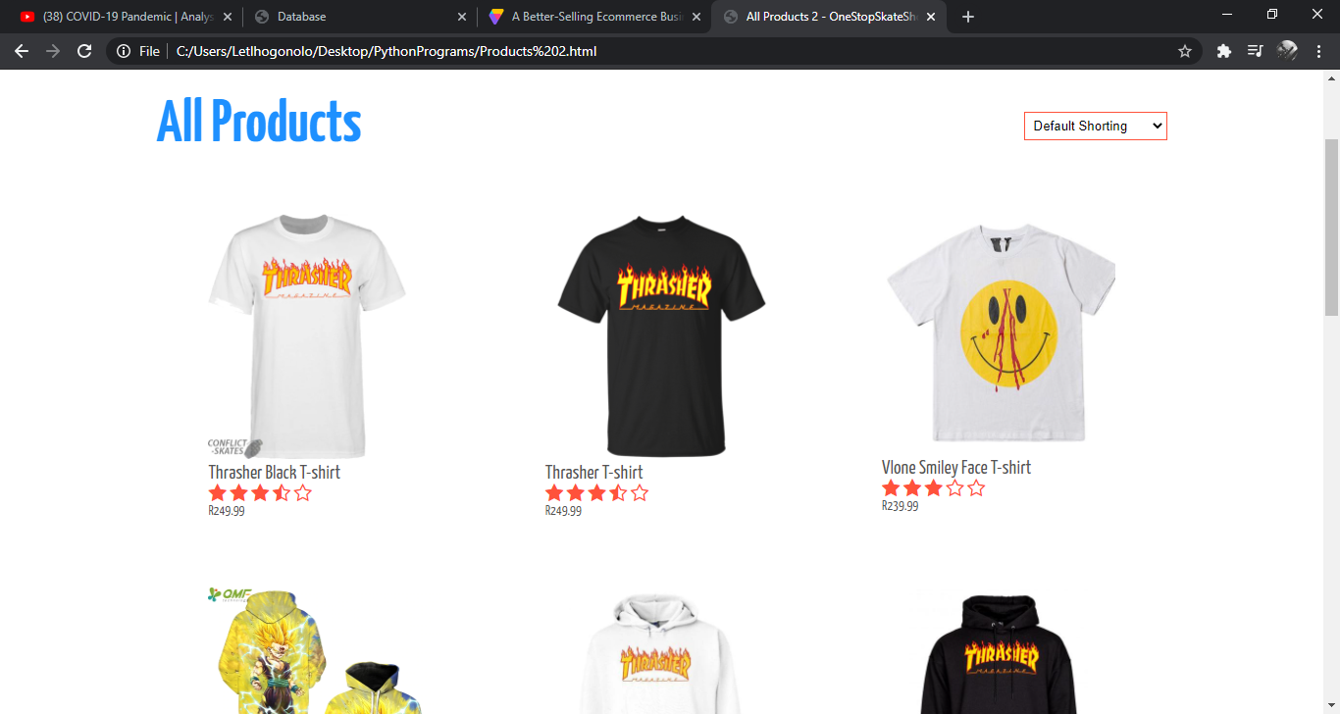

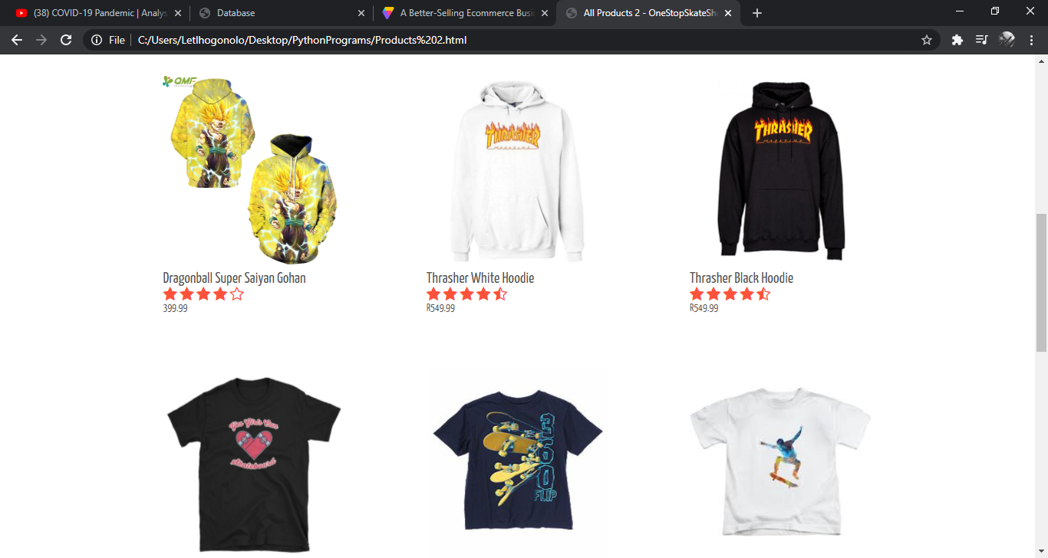

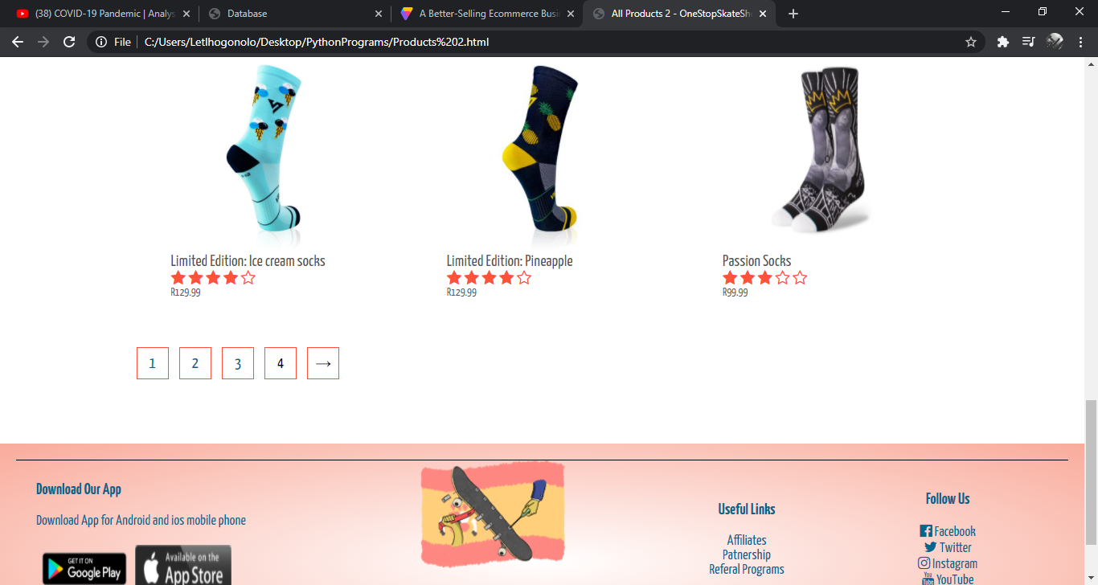

*Third and Final Products Page:*

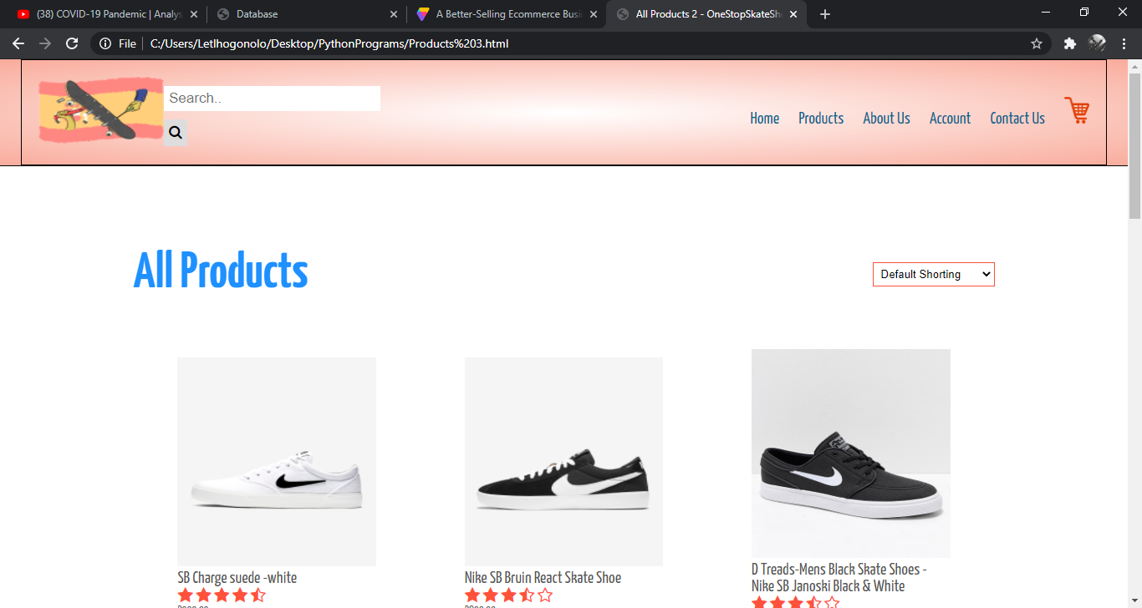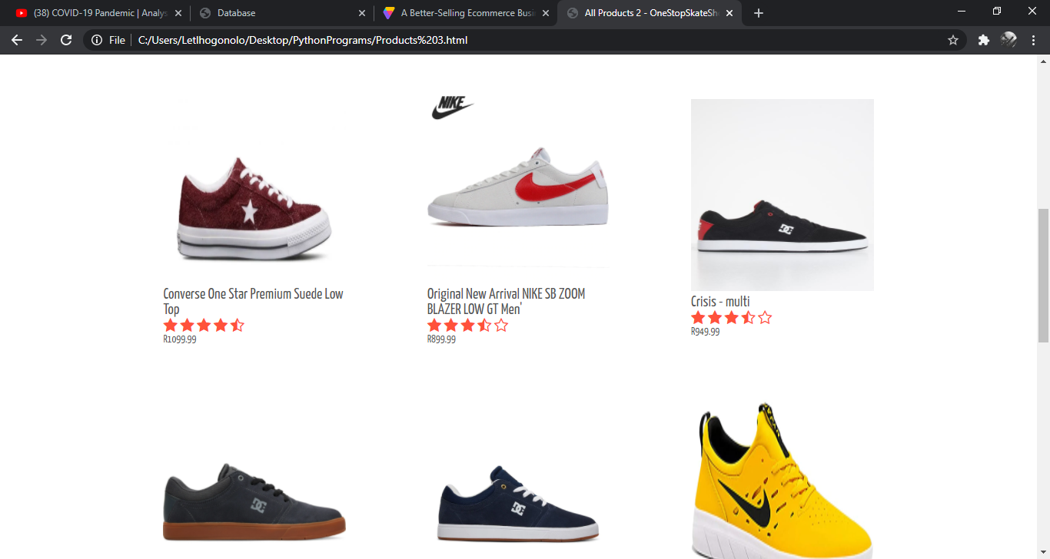

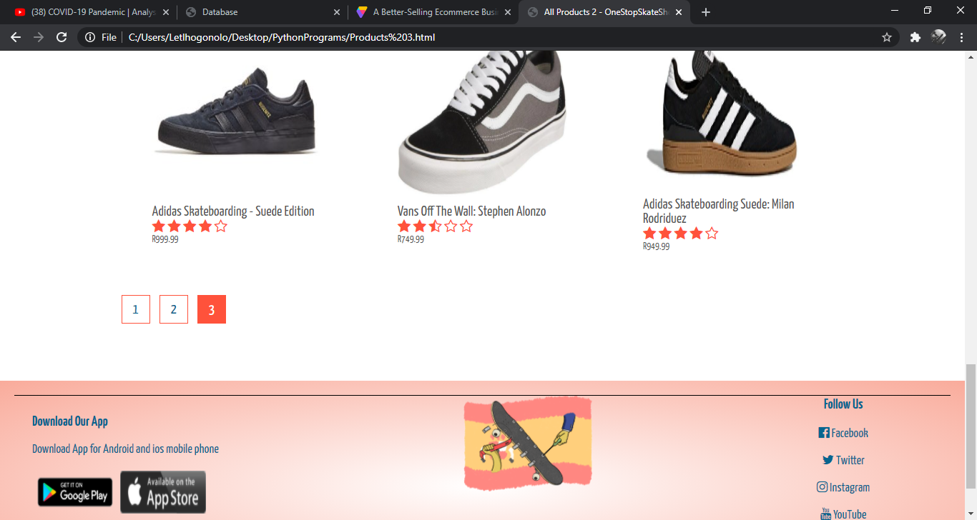

*About Us Page:*

This is where you will find details explaining what the company is all about and where to find products.

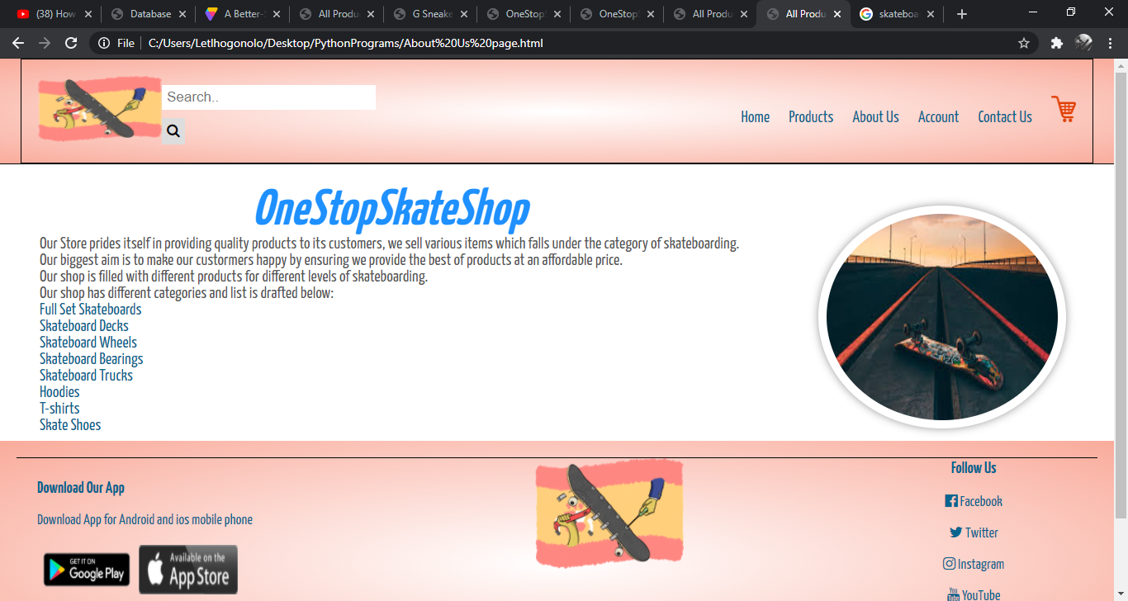

*Contact Us:*

On this section it is where our clients can keep in contact and communicate with us.

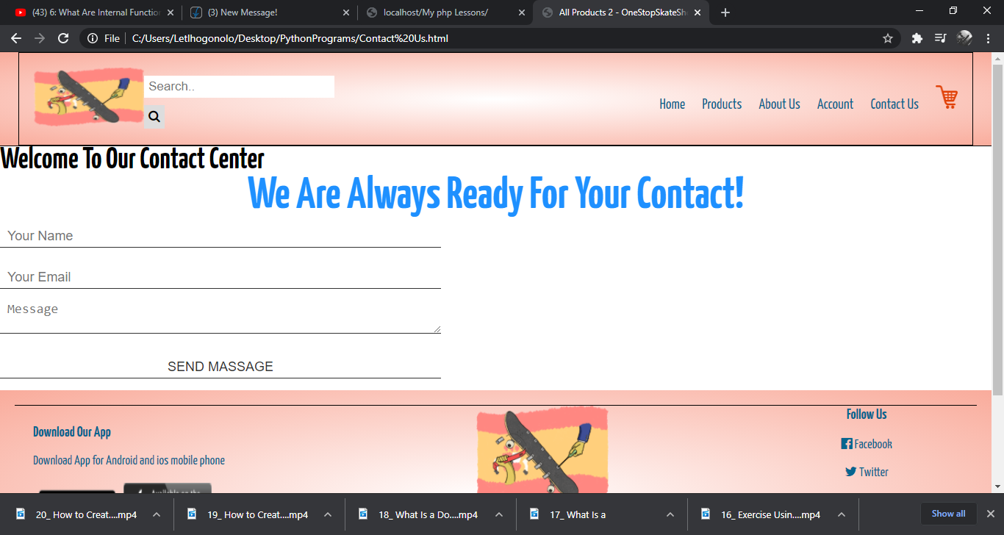

*Product Description Pages:*

This is where when our client gets sent when they want to purchase products from our store.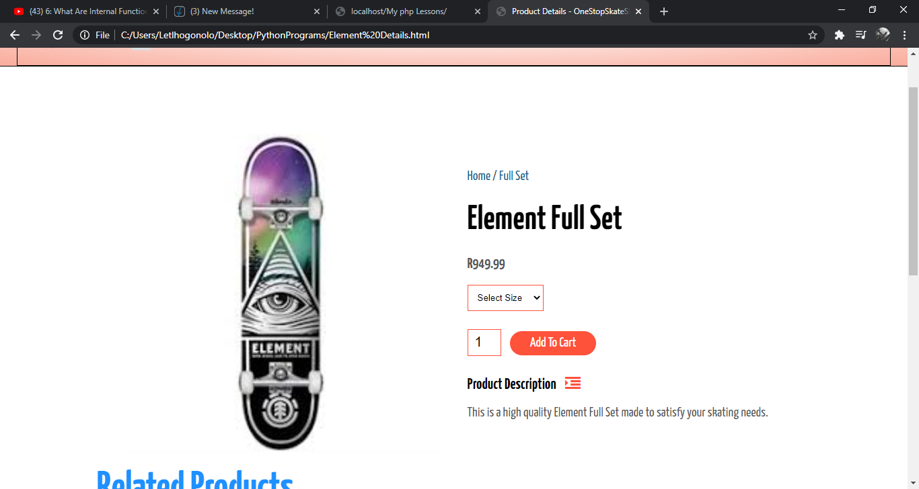

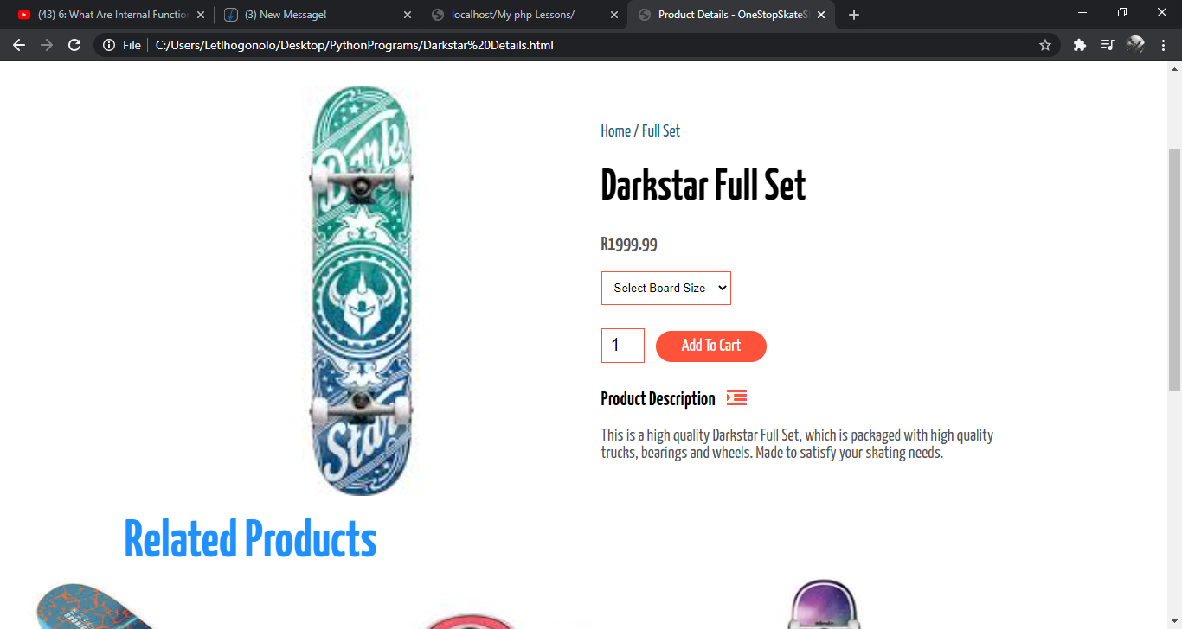

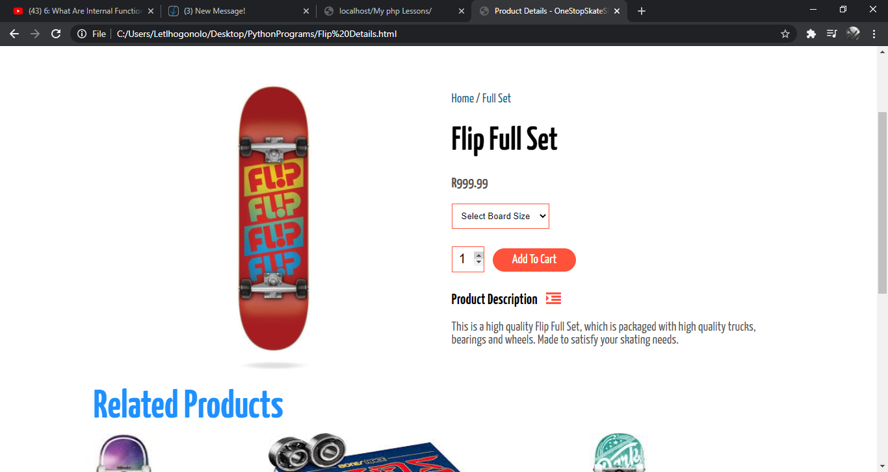

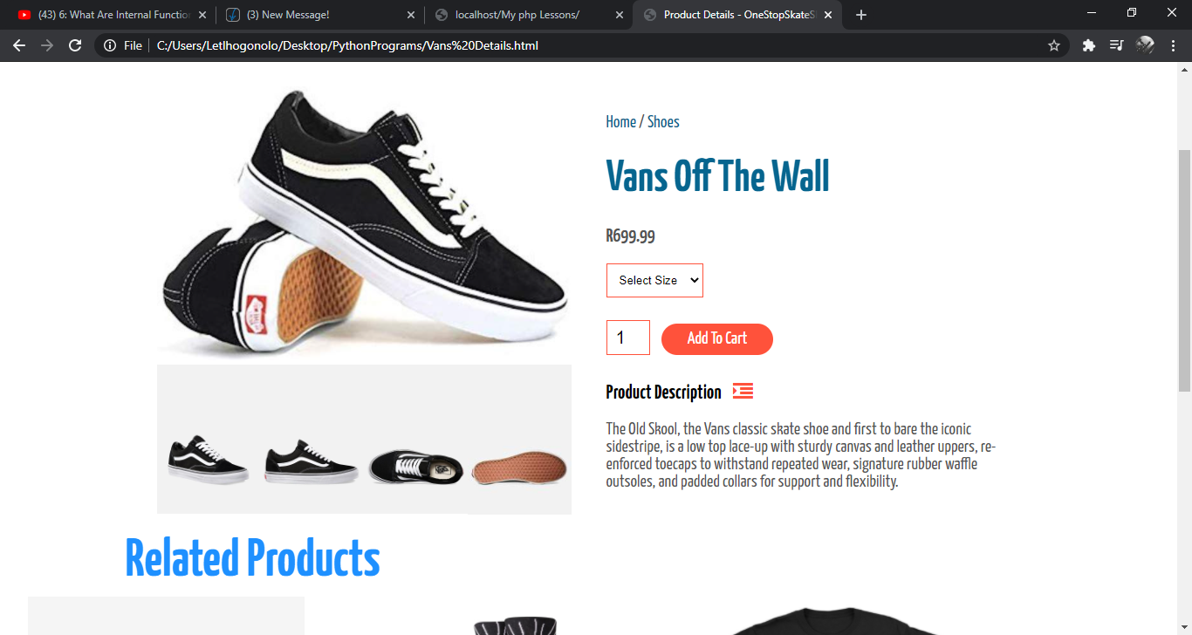

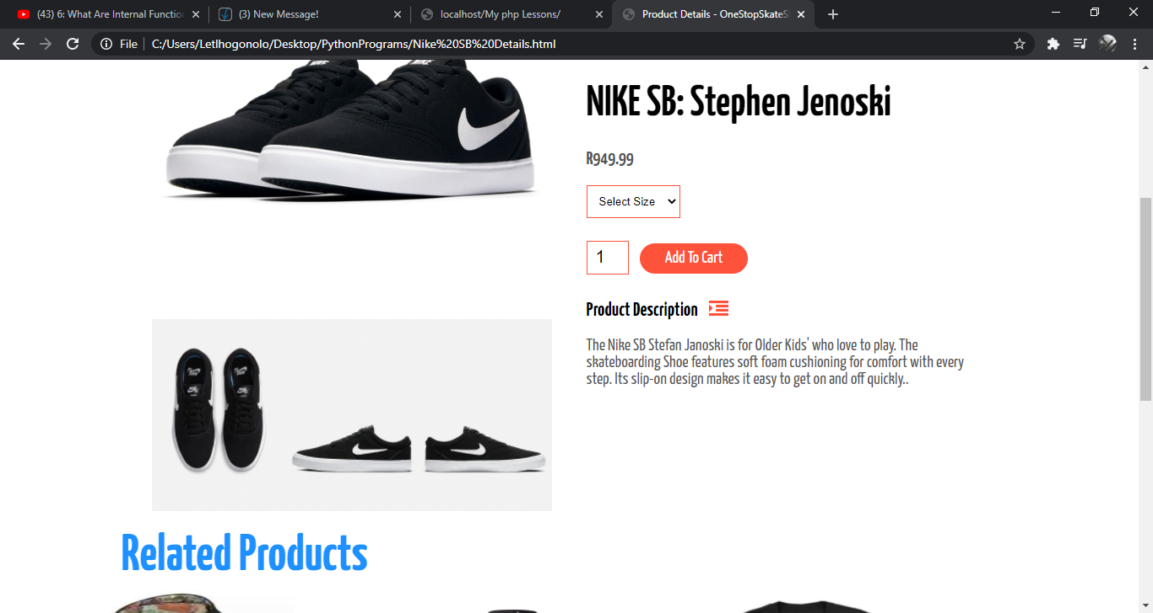

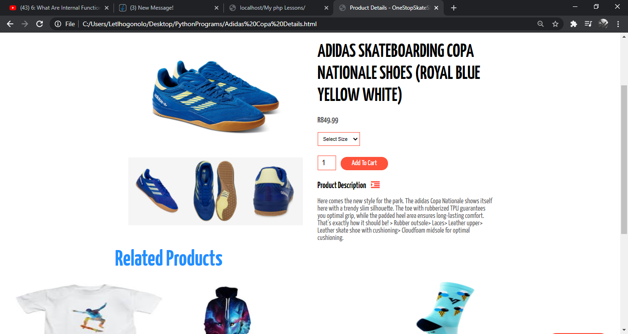

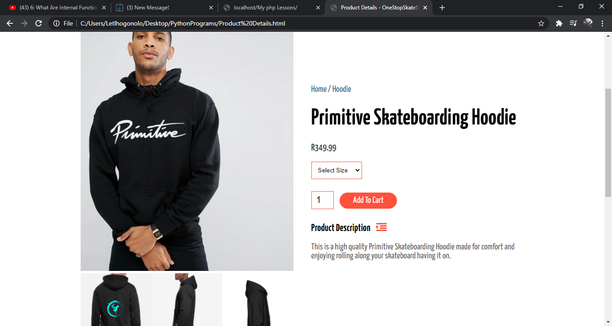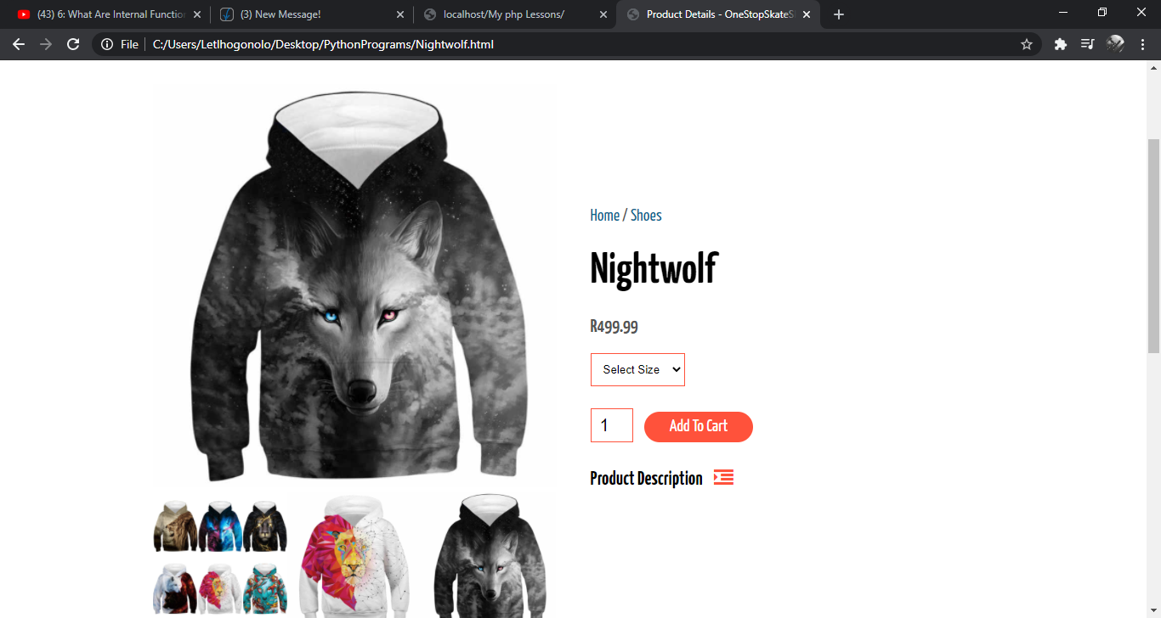

After products are selected to be bought you can simply click add to cart where it will redirect you to the cart where you will be able to process your payment.

*Cart Page:*

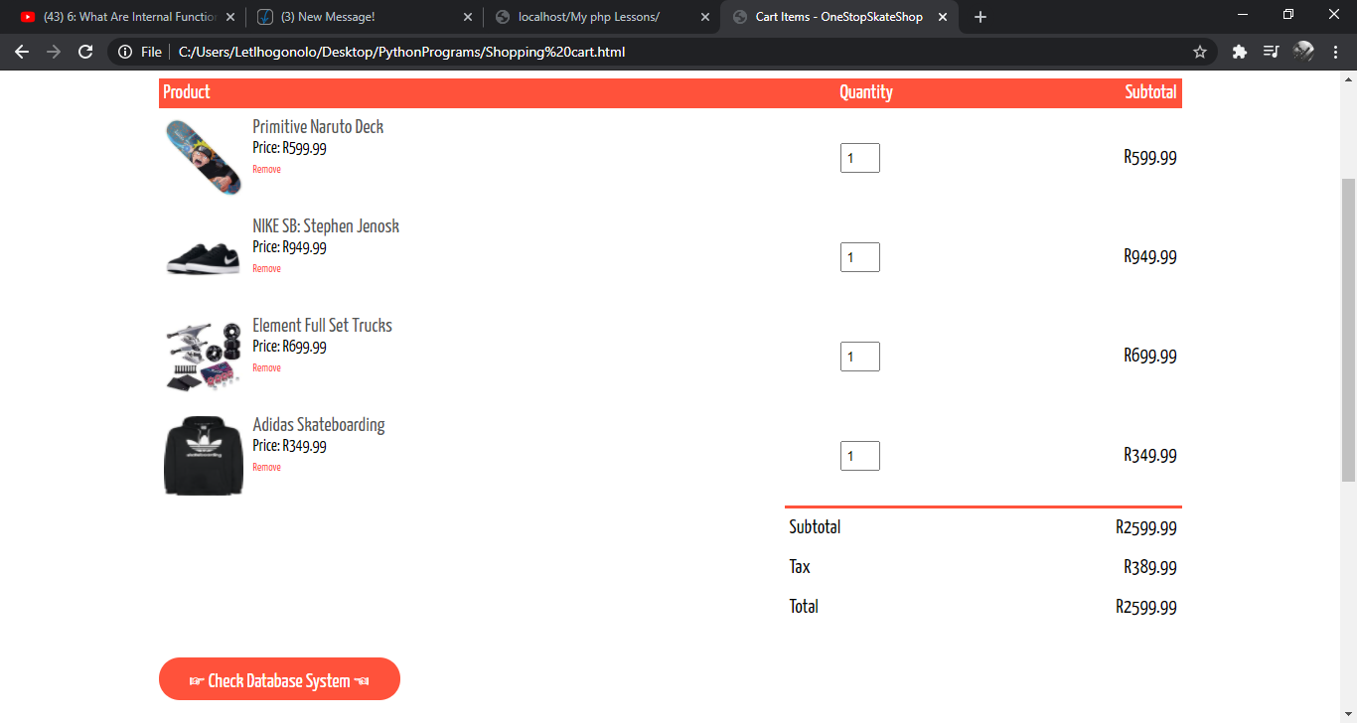

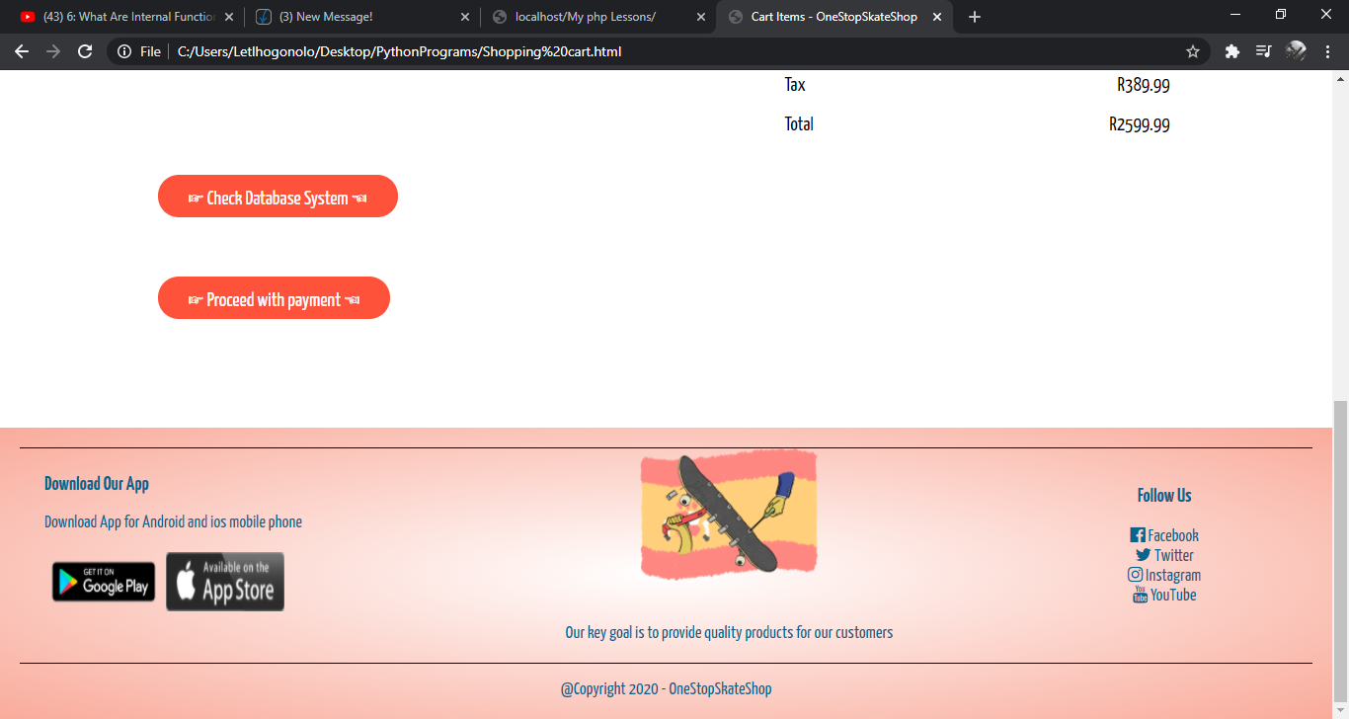

*Payment System Page:*

This is where payments are made and it is accessed via the Add To Cart Button:

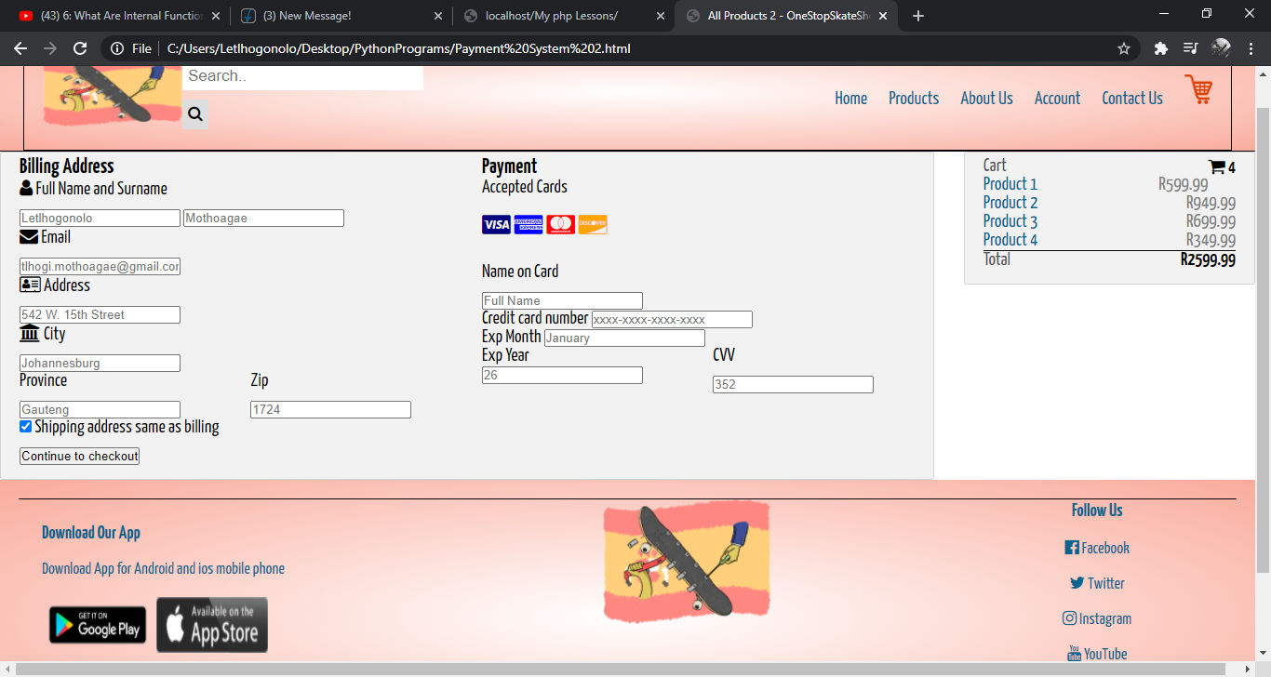

*Database System*

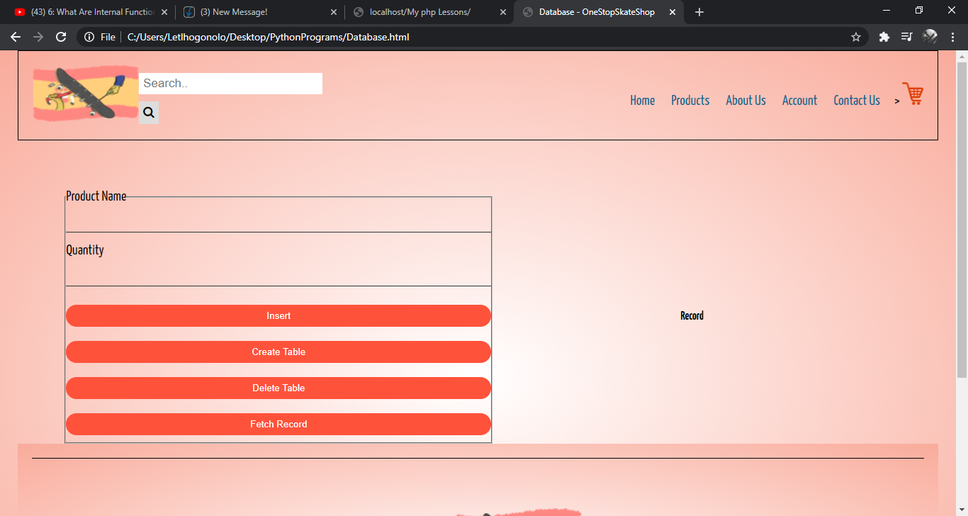

Every button on the website is highly effective and responsive.

Languages used on the website:

* Html
* Css
* Bootstrap
* Javascript
* Sql

The languages helped make the website responsive and easy to interact with.

*Source Codes:*

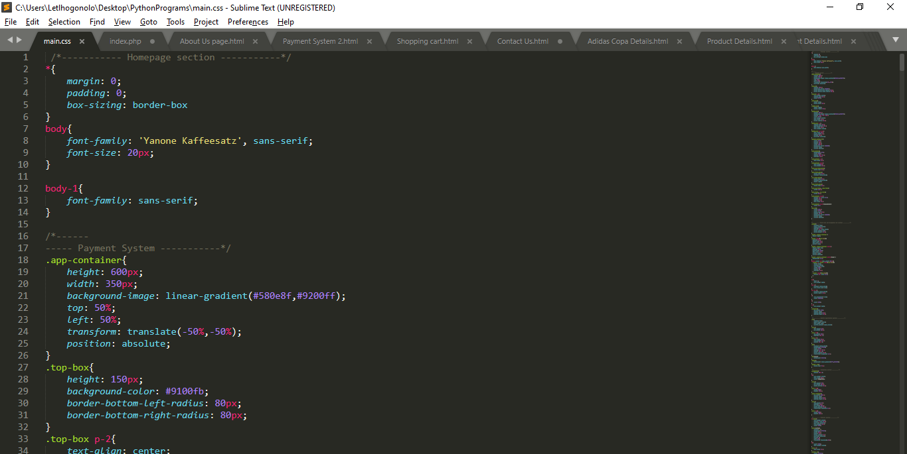

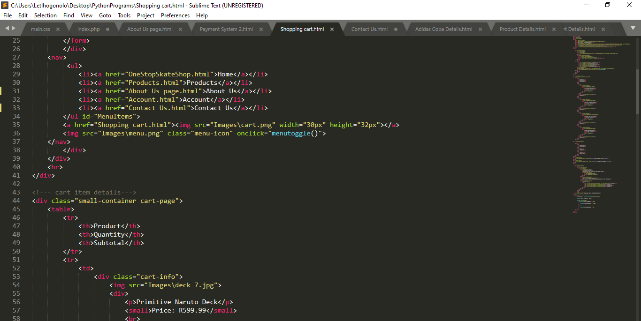

*Folder Structure:*



